Fat Tire Farm’s Spring Fling Downhill
Sunday May 8th, 2005
Saturday May 7th – training

Downhill Series is now the official State and Regional Championship Series


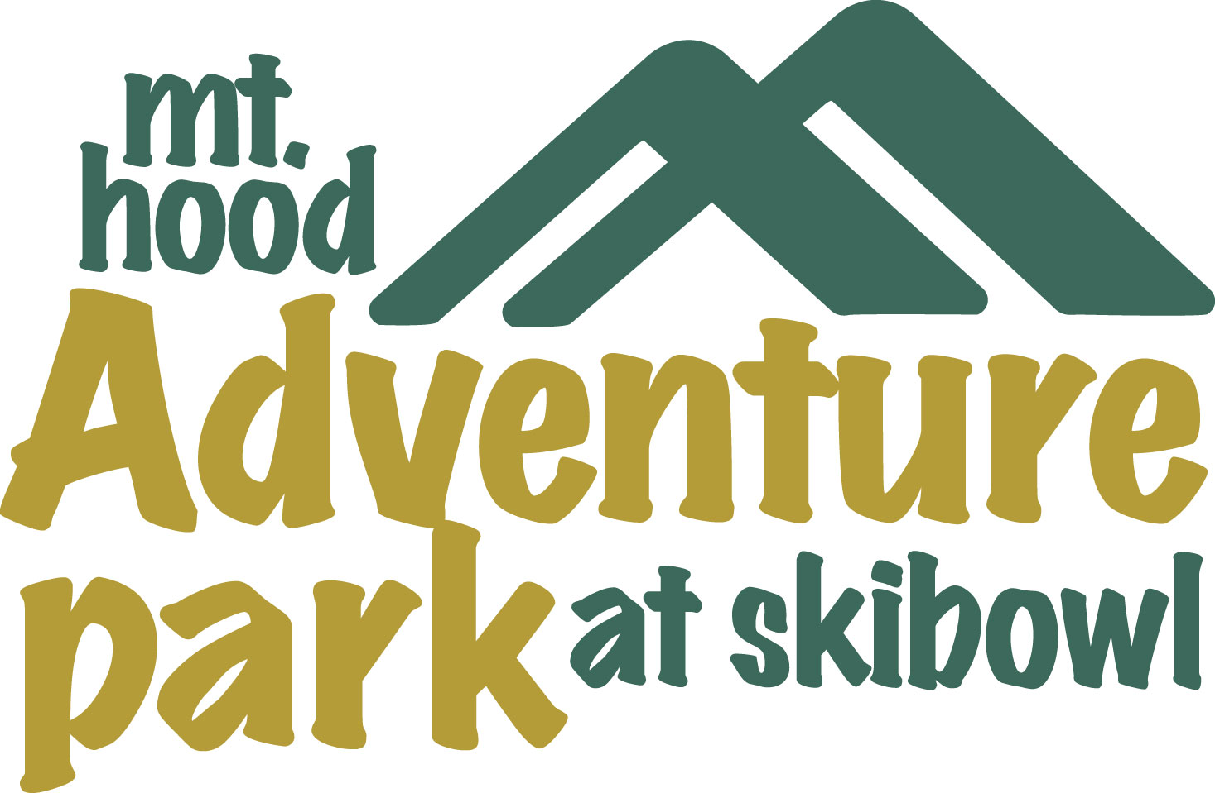
Race Info Line (503) 272-0146
Email: skibowlbikerace@aol.com
Website: www.skibowl.com
Hurricane Racing
P.O.Box 320, Government Camp OR 97028
Fax: (503) 272-0240

- Location: Mt. Hood Skibowl is located 52 miles S.E. of Portland on Hwy. 26, just before the village of Government Camp
- Registration forms: can be downloaded from www.Skibowl.com or www.OBRA.org.
- Pre-registration: Entrance deadline is Thursday prior to event. Mail application to Hurricane Racing, P.O.Box 320, Government Camp, OR 97028 or fax application to 503-272-0240. Please, no e-mail registrations. As usual your registration fee will not be processed until we see your smiling face!
Download your entry form at www.Skibowl.com or www.OBRA.org. You must have 1-day / seasonal
OBRA or NORBA license to be able to race (can be purchased on site). Annual licenses can also be
purchased at www.OBRA.org or www.usacycling.org.
- Late Registration: For those of you who don’t want to save $5.00 we will hold registration on Saturday 11:00am-4:00pm & Sunday 9:00am-11:00am. And yes, there is a late fee of $5.00.
- Entry fee: $25.00 for all categories and classes (plus $10.00 lift ticket for Saturday training)
- Events: Downhill training on Saturday and race on Sunday.
- Training: Saturday 12:00pm-4:00pm. Sunday lifts open at 10:00am; course closes at 11:00am. Anyone on the course after 11:00am will be disqualified (no refund).
- Start: 12:00pm 1st run Pro/Elite/Exp followed by single runs for hard tail/Sport/Beginners, then the 2nd run for Pro/Elite/Exp.
- Course: Separate courses will be designed for each class. Since there is still snow on Upper Bowl we will have just multiple run format on the Lower Bowl (3 runs for all categories, 2 counts).
- Awards/Raffle: Following the last Pro/Expert rider in the finish area (app. 3pm).
- Parking: at Skibowl parking lot.

